**Summary of Our Findings**

Question we are asking: What were the general trend of unemployment, house prices, and birth rates resulting from the Global Financial Crisis? Can we draw any conclusions for our project?

**Part #1 Unemployment Rates vs CLF (Civilian Labor Force)**

1. How can the size of the CLF affect the trend/rate of unemployment in different states?

* We binned the Unemployment Rate vs States CLF in two different bins. One with Unemployment Rate vs States CLF (<1,000,000) and one with Unemployment Rate vs States CLF (>5,000,000).
* Upon binning the two bins, we seen that every state regardless of the CLF size had its unemployment peak from 2009-2010 and thereafter the trend decreased. Some states decreased more drastically than others.
* Size of the CLF had no impact on the general trend of decrease in unemployment shown below.

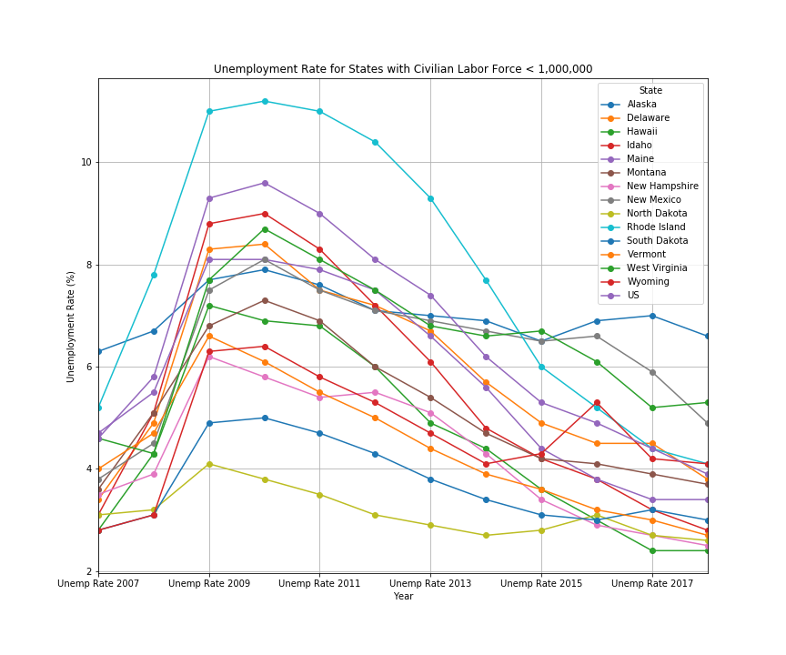

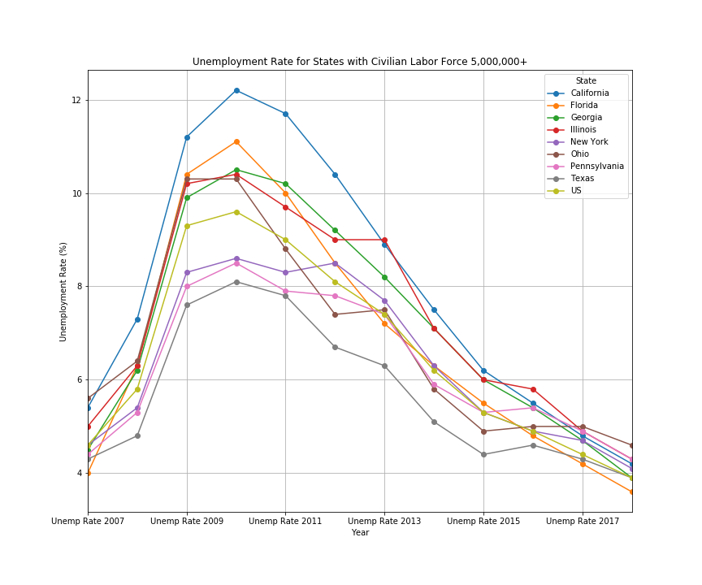

1. With two states of vastly different CLF sizes, we can see that regardless of the population of the CLF, the unemployment rate still follows the trend of peaking at 2009-2010 but then slowly decreasing. They even have similar R-values, meaning they have similar strength and direction between the two variables shown below.

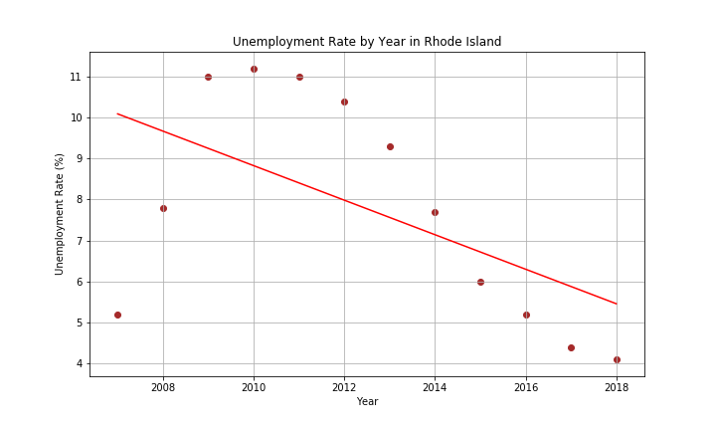

R-value: -0.551

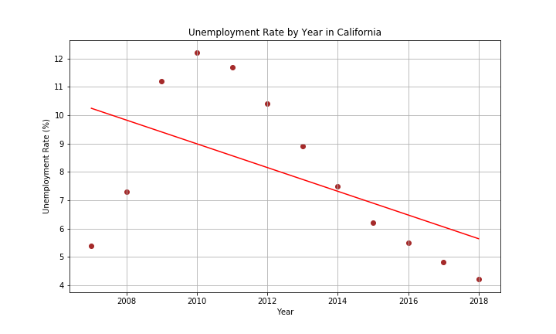

R-value: -0.528

**Part #2 Median House Price- Rhode Island vs California**

1. How does Median House Price relate to the CLF for these two states?

* It does not. CLF has no impact on starting the trend of increasing house prices after the recession.
* To show this, we binned the starting median house price by states different starting prices. The bin that had starting price for houses at $500,000 had both Rhode Island and California in them. When compared to each other to see the trend of house prices, both states show similar trend of eventually house prices steadily increasing.
* Size of CLF had no correlation with the increase in house prices.

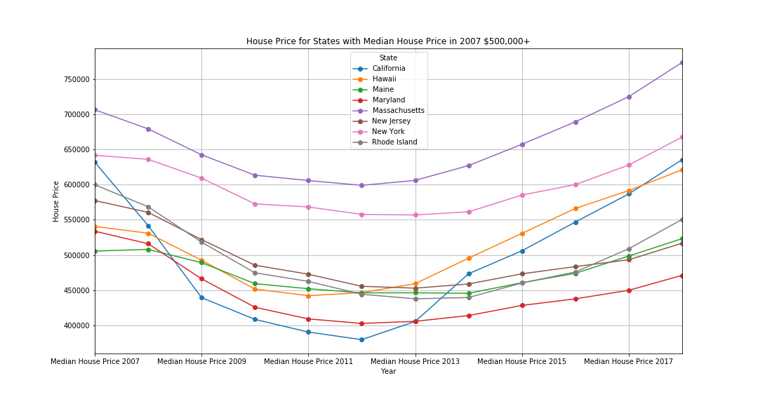

**Part #3 Unemployment Rates vs Median House Price in California/Rhode Island:**

1. Is there a relationship between the unemployment rate in a State to the median house price in California?

* Yes, as you can see there is an inverse relationship where the median house prices decreased as unemployment rose. Throughout time, median house prices increased as unemployment decreased back to pre-recession levels.
* Second Chart: Size of dot indicates which year. Smaller dots are previous years with the smallest being 2007 and the biggest being 2018
* Biggest dot going below the smaller dot shows that unemployment decreased to near pre-recession levels. However, it has shown that median house prices have increased from pre-recession to post-recession.
* 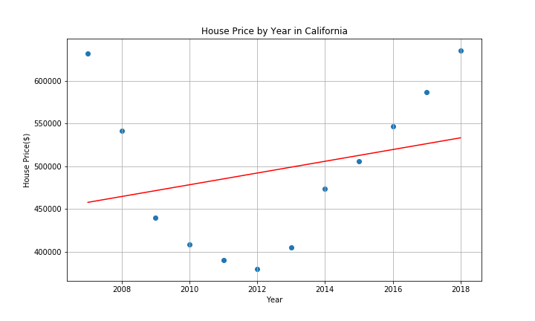

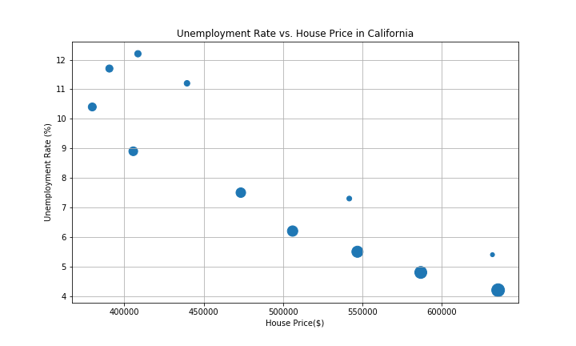

1. Is there a relationship between the unemployment rate in a State to the median house price in Rhode Island?

* Yes, there is an inverse relationship here between Unemployment Rate and Median House Price similar to California.
* When unemployment rose, median house prices decreased. When unemployment decreased, median house prices increased.
* Second Chart: Size of dot indicates which year. Smaller dots are previous years with the smallest being 2007 and the biggest being 2018
* Biggest dot going below the smaller dot shows that unemployment decreased over time. However, it has shown that median house prices have steadily increased. Although not as high as California’s house prices but they follow a similar pattern of increase.

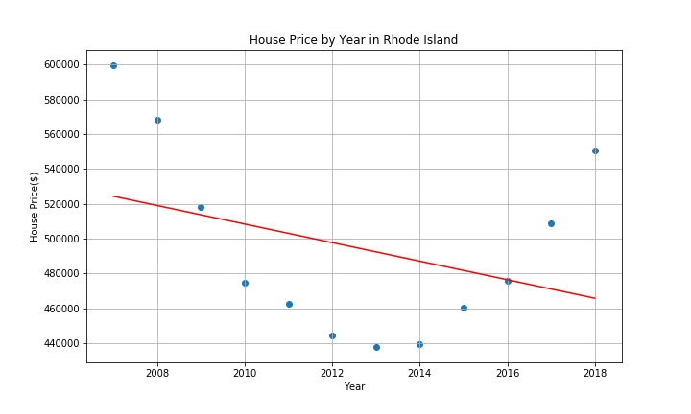

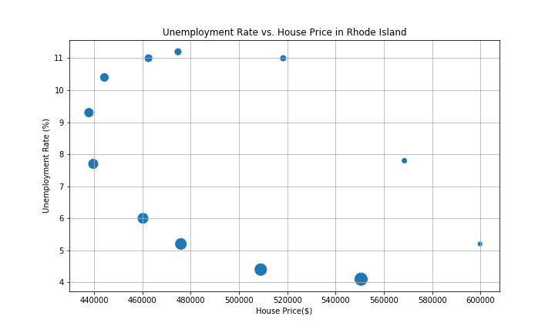

1. What can we say about the unemployment rate/median house price relationship between California and Rhode Island?

* Regardless of the CLF size in a state, there is a general trend of an inverse relationship between the unemployment rate and median house price in a particular state.

**Part 4: Unemployment Rates vs Birth Rates**

1. I am expecting an increase in birth rates in highest regions as unemployment decreases. Is that what happened after the recession?

* We broke down the birth rates into 10 regions and will show you the region of the birth rates with the highest and lowest births and compare that with the unemployment levels of that region.

*Graph showing lowest birth rates region and its unemployment levels*

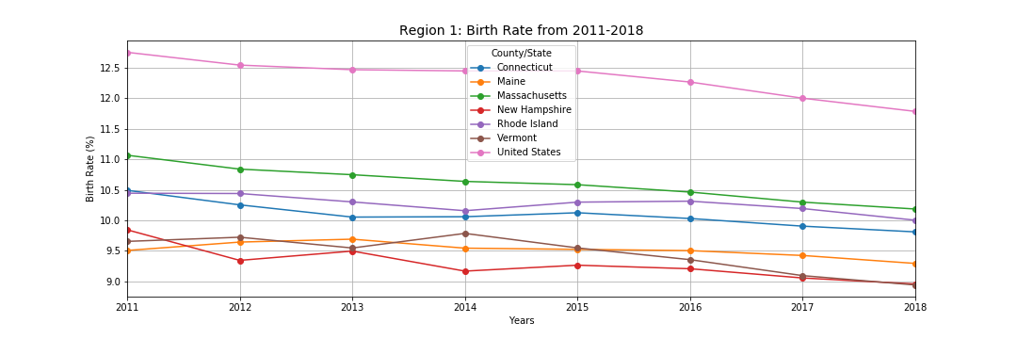

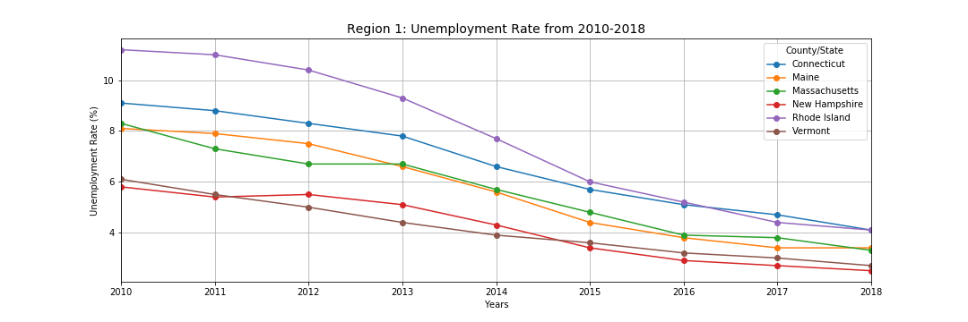

*Graph showing highest birth rates region and its unemployment levels*

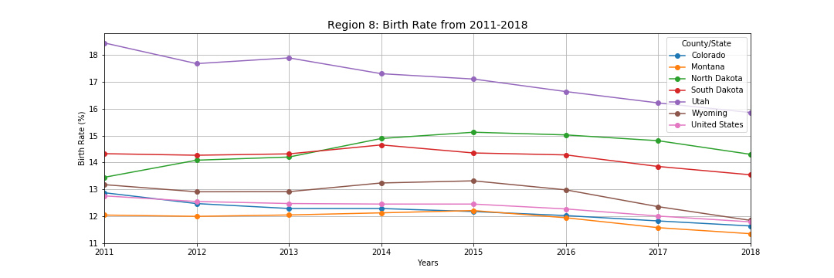

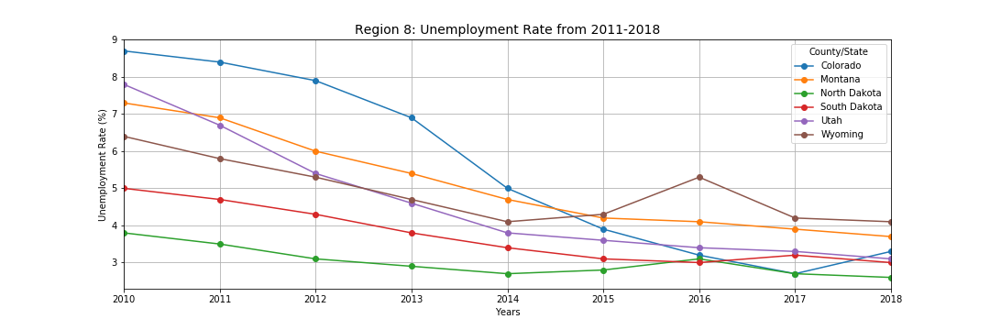

* We expected to see a birth rate increase as unemployment rates decreased, but it DID NOT happen in neither regions that we binned.
* Can conclude that birth rate and unemployment rate do not have a correlation today as expected.

**Final Conclusions**

1. The size of the CLF does not give a good indicator of why a certain state has an overall high/low unemployment rate for the past 12 years.
2. The CLF of a state doesn’t influence what the starting price of house is and what the trend of the median house prices will be as shown with Rhode Island and California.
3. Regardless of the CLF size, Unemployment rate and median house prices have an inverse relationship with another. Median house prices increase in a state as unemployment rates decrease. Vice versa.
4. The birth rates per region of highest/lowest births aren’t helping us draw an inverse relationship as we expected.